Chapter 19, Solution 19.

Using Fig. 19.80, design a problem to help other students to better understand how to find y parameters in the s-domain.

Although there are many ways to solve this problem, this is an example based on the same kind of problem asked in the third edition.

Problem

Find the y parameters of the two-port in Fig.19.80 in terms of s.

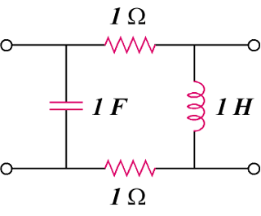

Figure 19.80

Solution

Consider the circuit in Fig.(a) for calculating 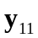 and 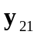.
1
(a)
+
V₂ = 0
−
V₁
+
−
I₁
I₂
1
s
1/s
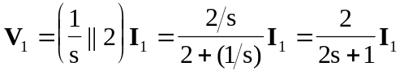
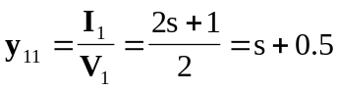

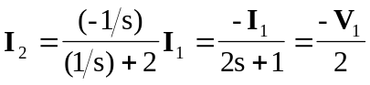
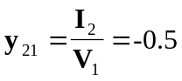

To get 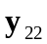 and 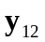, refer to the circuit in Fig.(b).
(b)
+
V₁ = 0
−
+
−
I₁
I₂
V₂
1
1
s
1/s

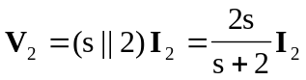
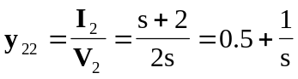

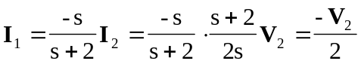
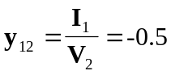

Thus,
